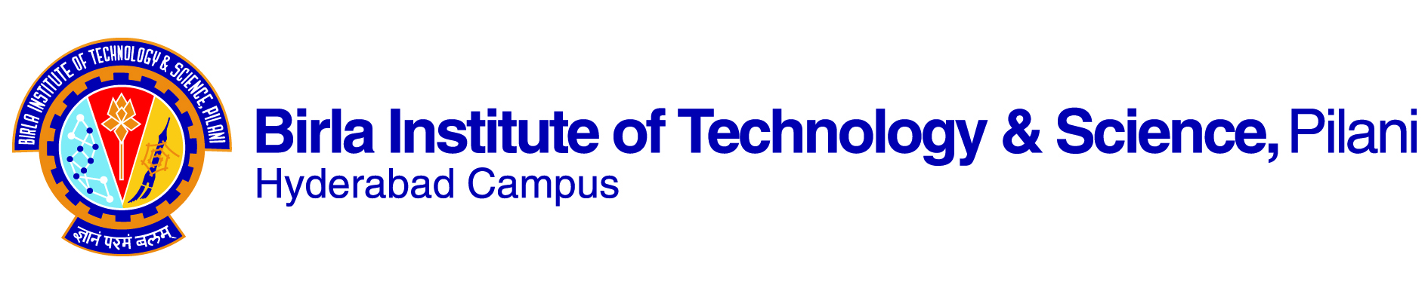

**SECOND SEMESTER 2022-2023**

# Course Handout Part II

Date: 16-01-2023

In addition to part-I (General Handout for all courses appended to the time table) this portion gives further specific details regarding the course.

*Course No.* : **CS F315**

## Course Title : **Information and Communication Technologies and Development**

## Instructor : Dipanjan Chakraborty

**Scope and Objective of the Course:**

This course will introduce students to understanding the societal challenges of the world and if and how Information and Communication Technologies can tackle them. After the successfully completing the course, the students will:

1. learn about the different application areas (SDGs. MDGs, etc.) where Information and Communication Technologies can play a catalytic role
2. learn to appreciate that technology is not a silver bullet, there are several other factors that need to be in place to create an environment in which technology can succeed
3. learn that an impactful technology does not need to be complex, the simplest of technologies can have big impact
4. learn to appreciate diversity among technology users, learn to put users at the centre of any technology, learn to conduct effective user-studies
5. learn about tech-determinism and its pitfalls
6. learn about the Human Factors in Computing

**Reference books:**

* 1. **Aaditeshwar Seth. Technology and (Dis)Empowerment: A Call to Technologists.** 2022. Emerald Publishing
  2. **Payal Arora. The Next Billion Users.** First Edition, 2019. Harvard University Press.
  3. **Amartya Sen and Jean Dreze. An Uncertain Glory: India and Its Contradictions.** 2020. Penguin Books

# **Amartya Sen. Development as Freedom.** 2000. Anchor Books.

* 1. **Jean Dreze. Sense And Solidarity - Jholawala Economics for Everyone.** 2017. Permanent Black
  2. **Ian Smillie. Mastering the Machine Revisited.** 2006. First Edition Reprint.
  3. **Richard Heeks. Information and Communication Technology for Development (ICT4D).** 2018. Routledge.
  4. **Cathy O’Neil. Weapons of Math Destruction.** 2017. Penguin Random House
  5. **Safiya Umoja Noble. Algorithms of Oppression.** 2018. New York University Press.
  6. **Kentaro Toyama. Geek Heresy.** 2015. Public Affairs
  7. **Shoshana Zuboff. The Age of Surveillance Capitalism.** 2019. Profile Books
  8. **Tim Wu. The Attention Merchants.** 2017. The Atlantic Books
  9. **Arun Mohan Sukumar. Midnight’s Machines.** 2019. Penguin Random House India
  10. **John Zerilli et al. A Citizen’s Guide to Artificial Intelligence.** 2021. The MIT Press
  11. **Ruha Benjamin. Race After Technology.** 2019. Polity Press
  12. **Sheera Frenkel and Cecilia Kang. An Ugly Truth.** 2021. The Bridge Street Press.
  13. Additional Reading Materials to be circulated

**Course Plan:**

|  |  |  |  |
| --- | --- | --- | --- |
| **Lecture No .** | **Learning Outcomes** | **Topic(s)** | **Chapters/Reading Materials** |
| 1 | To motivate the students for the course | What is development, can ICTs lead to development, and the need for this course | R4: Introduction R3: Ch 2  R1: Ch 1 |
| 2 | Models of social developments and their pros and cons | Extra reading material |
| 3 – 4 | To acquaint students with some case studies in ICTD which did not lead to favourable outcome | Case studies with unfavourable outcome (Tech Determinism) | R2: Ch 6 |
| 5 – 6 | R10: Ch 1 |
| 7 – 8 | R5: Ch 8 |
| 9 – 10 | R10: Ch 3 |
| 11 – 12 | To acquaints students with the inequalities in society and their ramifications | Inequalities: gender divide, digital divide | R6: Ch XIII |
| 13 – 14 | R2: Ch 1 |
| 15 | Reading material: Smartphone Ownership Is Growing Rapidly Around the World, but Not Always Equally |
| 16 – 17 | R1: Ch 6 |
| 18 – 22 | To acquaint students with the ethical underpinnings of technology | Ethics in applied computing | R8: Ch 4, 5, 6, 8, 9, 10 |
| 23 | Reading Material: Gig Economy |
| 24 | Reading Material: The limits of “design ethics” under capitalism |
| 25 | R1: Ch 4, 5 |
| 26-27 | R15: Ch 1, 2, 3 |
| 28 | R14: selected chapters |
| 29 | R12: selected chapters |
| 30 | R11: selected chapters |
| 31 | R9: selected chapters |
| 32 – 33 | To acquaint students with the ramifications of big technology companies influencing public policy | Big Tech and its problems | Reading Material: Defund Big Tech, Refund Community · Tech Otherwise |
| R16: selected chapters |
| 34 – 37 | To acquaint students with different theories and frameworks in the ICTD domain | ICTD theories and frameworks | R10: Ch 2, 6, 7, 9 |
| 38 | R7: Ch 1.3 |
| 39 – 40 | To motivate the students to think of a way forward to work in this domain | The way forward | R1: Ch 7, 8  R15: Ch 4, 5 |

**Evaluation Scheme:**

|  |  |  |  |  |
| --- | --- | --- | --- | --- |
| **Component** | **Duration** | **Weightage (%)** | **Date & Time** | **Nature of Component** |
| Comprehensive examination | 3 hours | 30% | 18th May, AN | Partially Open Book |
| Mid-term examination | 1.5 hours | 20% | 17th March, 16:00-17:30 | Partially Open Book |
| Course Project | - | 20%  (proposal: 5 %  Mid-term: 5%  End-term: 10%) | continuous | Open (In class) |
| Course Debates | - | 10% | continuous | Open (In class) |
| Reading Assignments | - | 15% | continuous | Open (Take home) |
| Class Participation | - | 5% | continuous | open |

Mid Term grading: Mid-term examination (20%) + Project Proposal (5%) + Project Mid-term (5%) + Reading Assignments (10%) = 40%

**Consultation Hour:** TBA

**Notices:** To be circulated through CMS and/or Piazza

**Make-up Policy:**

* Mid-term and Comprehensive examinations: prior permission from the I/C is necessary. Make-up might be granted only in very serious health related cases
* Other components: no make-up allowed, rescheduling may be allowed at the discretion of the I/C in urgent and genuine cases.

**Academic Honesty and Integrity Policy:**

Academic honesty and integrity are to be maintained by all the students throughout the semester and no type of academic dishonesty is acceptable.

**INSTRUCTOR-IN-CHARGE**